RAILWAY MANAGEMENT SYSTEM
A MINI-PROJECT REPORT
Submitted by

AAKASH A 241801001
ANGELIN BLESSY J A 241801021
DARSHAN C S 241801039

in partial fulfillment of the award of the degree
of
BACHELOR OF ENGINEERING
IN
ARTIFICIAL INTELLIGENCE AND DATA SCIENCE

RAJALAKSHMI ENGINEERING COLLEGE, CHENNAI
An Autonomous Institute
CHENNAI
NOVEMBER 2025

BONAFIDE CERTIFICATE
Certified that this project “RAILWAY MANAGEMENT SYSTEM” is the bonafide work of “AAKASH A, ANGELIN BLESSY J A , DARSHAN C S ” who carried out the project work under my supervision.

SIGNATURE
Dr.R. Savithri
ASSISTANT PROFESSOR SG
Dept. of Artificial Intelligence and Data Science,
Rajalakshmi Engineering College
Chennai

This mini project report is submitted for the viva voce examination to be held on __________

INTERNAL EXAMINER EXTERNAL EXAMINER
ABSTRACT

Transportation is a critical backbone for large populations and economies. The Railway Management System aims to digitalize railway operations including ticket booking, train schedules, class-based seat allocation, and user management through an integrated web platform. The system encompasses an Admin interface for train and station management and a Passenger portal for searching trains and booking seats (including class selection such as Sleeper, 3A, 2A, 1A, 3E, 2S). Designed using HTML and CSS (frontend), Python (backend), and MySQL (database), the project implements smart search, dynamic seat management, and secure logins to deliver a seamless experience. It serves as a practical example of applying full-stack development for real-world logistics and scheduling problems.

ACKNOWLEDGEMENT

We express our sincere thanks to our beloved and honorable chairman MR. S. MEGANATHAN and the chairperson DR. M.THANGAM MEGANATHAN for their timely support and encouragement.
We are greatly indebted to our respected and honorable principal
Dr. S.N. MURUGESAN for his able support and guidance.
No words of gratitude will suffice for the unquestioning support extended to us by our Head Of The Department Dr. J.M. GNANASEKAR and our Deputy Head Of The Department Dr. J. MANORANJINI for being ever supporting force during our project work
We also extend our sincere and hearty thanks to our internal guide Dr.R . SAVITHRI, for her valuable guidance and motivation during the completion of this project.
Our sincere thanks to our family members, friends and other staff members of computer science engineering.
1. AAKASH A
2. ANGELIN BLESSY J A
3. DARSHAN C S

TABLE OF CONTENTS

CHAPTER NO. TITLE PAGE NO
ABSTRACT iv

1 INTRODUCTION 1
1.1 INTRODUCTION 8
1.2 SCOPE OF THE WORK 8
1.3 PROBLEM STATEMENT
1.4 AIM AND OBJECTIVES OF THE PROJECT 8
2 SYSTEM SPECIFICATIONS 9
2.1 HARDWARE SPECIFICATIONS 9
2.2 SOFTWARE SPECIFICATIONS 9
3 MODULE DESCRIPTION 10
4 CODING 11
5 SCREENSHOTS 16
6 CONCLUSION AND FUTURE ENHANCEMENT 18
REFERENCES 19

FIGURE NO. | TITLE | PAGE NO.
5.1 | INTRODUCTION PAGE | 15
5.2 | CUSTOMER DETAILS | 15
5.3 | BOOKING LOG | 16
5.4 | BOOKING CREATION | 16
5.5 | DELETION OF BOOKING | 17
5.6 | DATABASE CREATION | 17
LIST OF FIGURES

CHAPTER 1
INTRODUCTION
1.1 INTRODUCTION
The Railway Management System enables both passengers and administrators to efficiently manage all aspects of train bookings and schedule management. Passengers can search for available trains using auto-complete station search, view real-time seat availability across various classes, and book tickets. The admin dashboard allows train and station management, fare setting, operational day configuration, and live occupancy monitoring. The system integrates database management, backend logic with Python, and a responsive frontend designed to give users an experience akin to professional booking sites.

1.2 SCOPE OF THE WORK
The system provides a digital interface for Indian Railways-like services, improving ticketing ease, data accuracy, and access to real-time information for passengers. It supports admin-controlled addition and management of trains, stations, fares, and schedules, offering flexibility to scale for national-level deployment.

1.3 PROBLEM STATEMENT
The project addresses the challenges found in traditional railway ticketing systems: manual booking errors, limited seat class management, lack of user-friendly digital interfaces, and difficulties in monitoring train occupancy and schedules. The new system ensures reliable seat allocation, smart class selection, and streamlined station/train management accessible online.

1.4 AIM AND OBJECTIVES OF THE PROJECT
The main objective of this project is to digitalize railway ticket booking, scheduling, and seat management by providing a web-based, multi-class, multi-user solution. Features include:
• Admin management for trains, stations, and fares.
• Passenger search, booking, and cancellation.
• Real-time seat allocation and class-based fare calculations.
• Secure user authentication for both admin and passenger users.

CHAPTER 2
SYSTEM SPECIFICATIONS
2.1 HARDWARE SPECIFICATIONS
Processor | : | Intel i5
Memory Size | : | 8GB (Minimum)
HDD | : | 1 TB (Minimum)

2.2 SOFTWARE SPECIFICATIONS
Operating System | : | WINDOWS 11
Front – End | : | HTML, CSS
Back - End | : | MySql, PYTHON
Language | : | python,SQL

CHAPTER 3
MODULE DESCRIPTION
This application consists of two modules, each accessible through separate login pages:
3.1 ADMIN LOGIN
The admin logs in with a secure ID and password. They can configure train and station details, update seating and fare structures, manage booking history, and oversee overall railway operations.
3.2 PASSENGER LOGIN
Passengers use their login credentials to access their dashboard, search for trains by station and date, select seat class, view fare, place booking, and cancel bookings if needed. Multi-class seat availability and MakeMyTrip-style booking logic are implemented.

CHAPTER 4
SAMPLE CODING
Sample 1
Sample 1 depicts the display code, that gets the data from the database i.e. being stored there and represented on users demand with the layout and measurements i.e. being already specified.
MAIN DATABASE CODE
import mysql.connector

conn = mysql.connector.connect(
host="localhost",
user="root",
password="user1234",
database="train_reservation_system"
)

if conn.is_connected():
print("✅ Database Connection Success")

mycursor = conn.cursor()

# 1. Admin Table
mycursor.execute("""
CREATE TABLE IF NOT EXISTS admin (
admin_id INT AUTO_INCREMENT PRIMARY KEY,
username VARCHAR(50) NOT NULL UNIQUE,
password VARCHAR(100) NOT NULL,
name VARCHAR(100),
email VARCHAR(100)
)
""")

# 2. Passenger Table
mycursor.execute("""
CREATE TABLE IF NOT EXISTS passenger (
passenger_id INT AUTO_INCREMENT PRIMARY KEY,
name VARCHAR(100) NOT NULL,
age INT CHECK(age >= 0),
gender VARCHAR(10),
email VARCHAR(100) UNIQUE,
password VARCHAR(100) NOT NULL,
phone BIGINT UNIQUE
)
""")

# 3. Station Table (NEW)
mycursor.execute("""
CREATE TABLE IF NOT EXISTS station (
station_id INT AUTO_INCREMENT PRIMARY KEY,
station_code VARCHAR(10) NOT NULL UNIQUE,
station_name VARCHAR(100) NOT NULL,
state VARCHAR(50),
INDEX idx_station_code (station_code),
INDEX idx_station_name (station_name)
)
""")

# 4. Train Table (UPDATED with new columns)
mycursor.execute("""
CREATE TABLE IF NOT EXISTS train (
train_id INT AUTO_INCREMENT PRIMARY KEY,
train_number VARCHAR(20) NOT NULL UNIQUE,
train_name VARCHAR(150) NOT NULL,
train_type VARCHAR(50),
source_code VARCHAR(10) NOT NULL,
source_name VARCHAR(100),
destination_code VARCHAR(10) NOT NULL,
destination_name VARCHAR(100),
departure_time TIME NOT NULL,
arrival_time TIME NOT NULL,
duration_hours DECIMAL(5,2),
operating_days VARCHAR(30) DEFAULT 'S M T W T F S',
total_seats INT NOT NULL CHECK(total_seats > 0),

-- Seat class details
sl_total_seats INT DEFAULT 0,
sl_available_seats INT DEFAULT 0,
sl_price DECIMAL(10,2) DEFAULT 0,

ac3_total_seats INT DEFAULT 0,
ac3_available_seats INT DEFAULT 0,
ac3_price DECIMAL(10,2) DEFAULT 0,

ac2_total_seats INT DEFAULT 0,
ac2_available_seats INT DEFAULT 0,
ac2_price DECIMAL(10,2) DEFAULT 0,

ac1_total_seats INT DEFAULT 0,
ac1_available_seats INT DEFAULT 0,
ac1_price DECIMAL(10,2) DEFAULT 0,

ac3e_total_seats INT DEFAULT 0,
ac3e_available_seats INT DEFAULT 0,
ac3e_price DECIMAL(10,2) DEFAULT 0,

second_total_seats INT DEFAULT 0,
second_available_seats INT DEFAULT 0,
second_price DECIMAL(10,2) DEFAULT 0,

base_fare DECIMAL(10,2) NOT NULL,
free_cancellation VARCHAR(3) DEFAULT 'No',
tatkal_available VARCHAR(3) DEFAULT 'Yes',
food_available VARCHAR(3) DEFAULT 'No',

INDEX idx_source (source_code),
INDEX idx_destination (destination_code),
INDEX idx_train_number (train_number)
)
""")

# 5. Booking Table (UPDATED)
mycursor.execute("""
CREATE TABLE IF NOT EXISTS booking (
booking_id INT AUTO_INCREMENT PRIMARY KEY,
passenger_id INT,
train_id INT,
journey_date DATE NOT NULL,
class_type VARCHAR(20) NOT NULL,
seats_booked INT NOT NULL CHECK(seats_booked > 0),
total_fare DECIMAL(10,2) NOT NULL,
booking_status VARCHAR(20) DEFAULT 'confirmed',
booking_date TIMESTAMP DEFAULT CURRENT_TIMESTAMP,
FOREIGN KEY (passenger_id) REFERENCES passenger(passenger_id) ON DELETE CASCADE,
FOREIGN KEY (train_id) REFERENCES train(train_id) ON DELETE CASCADE
)
""")

# 6. Waiting List Table
mycursor.execute("""
CREATE TABLE IF NOT EXISTS waiting_list (
wl_id INT AUTO_INCREMENT PRIMARY KEY,
passenger_id INT,
train_id INT,
position INT NOT NULL,
status VARCHAR(20) DEFAULT 'waiting',
FOREIGN KEY (passenger_id) REFERENCES passenger(passenger_id) ON DELETE CASCADE,
FOREIGN KEY (train_id) REFERENCES train(train_id) ON DELETE CASCADE
)
""")

# 7. Train Status Table
mycursor.execute("""
CREATE TABLE IF NOT EXISTS train_status (
status_id INT AUTO_INCREMENT PRIMARY KEY,
train_id INT,
status VARCHAR(20) DEFAULT 'On Time',
delay_minutes INT DEFAULT 0,
current_station VARCHAR(100),
last_updated TIMESTAMP DEFAULT CURRENT_TIMESTAMP ON UPDATE CURRENT_TIMESTAMP,
FOREIGN KEY (train_id) REFERENCES train(train_id) ON DELETE CASCADE
)
""")

# 8. Feedback Table
mycursor.execute("""
CREATE TABLE IF NOT EXISTS feedback (
feedback_id INT AUTO_INCREMENT PRIMARY KEY,
passenger_id INT,
message TEXT NOT NULL,
date TIMESTAMP DEFAULT CURRENT_TIMESTAMP,
resolved BOOLEAN DEFAULT FALSE,
FOREIGN KEY (passenger_id) REFERENCES passenger(passenger_id) ON DELETE CASCADE
)
""")

print("✅ All tables created successfully!")

# Commit all changes
conn.commit()
print("✅ All changes committed to database.")

# Close connection
mycursor.close()
conn.close()
print("✅ Database connection closed.")

CHAPTER 5
SCREEN SHOTS

Fig 5.1 Introduction page
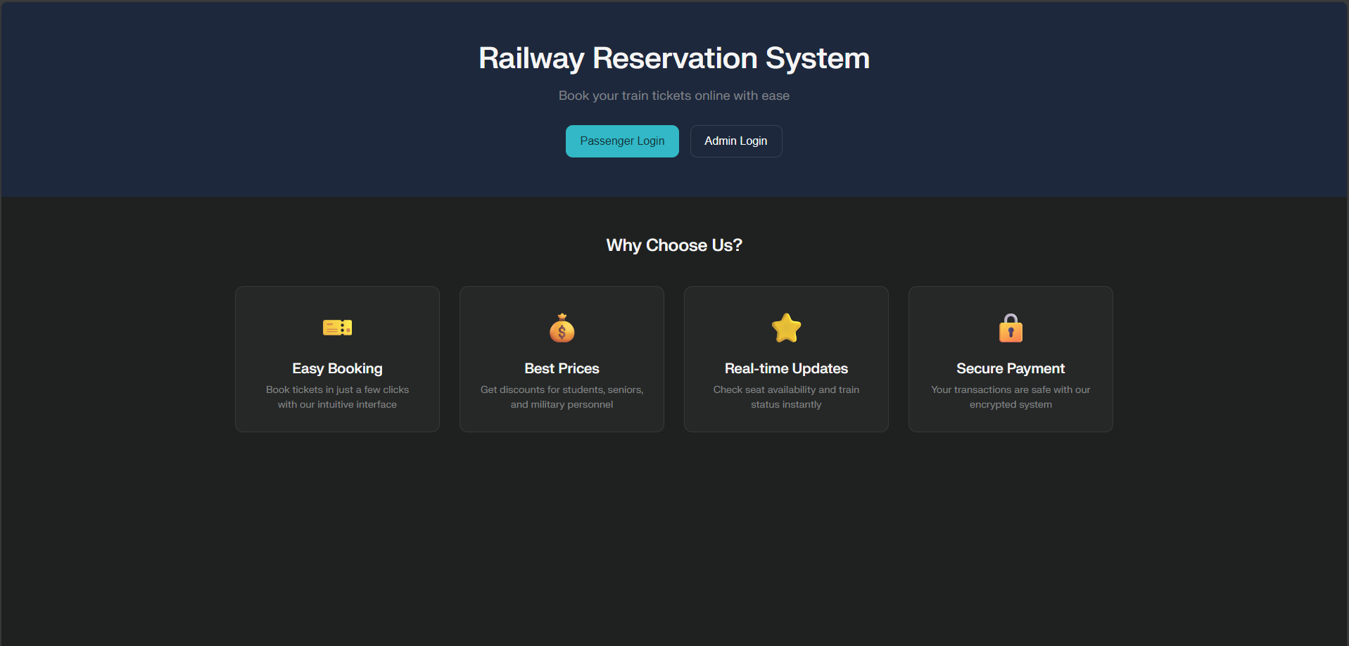
Fig 5.2 Customer details
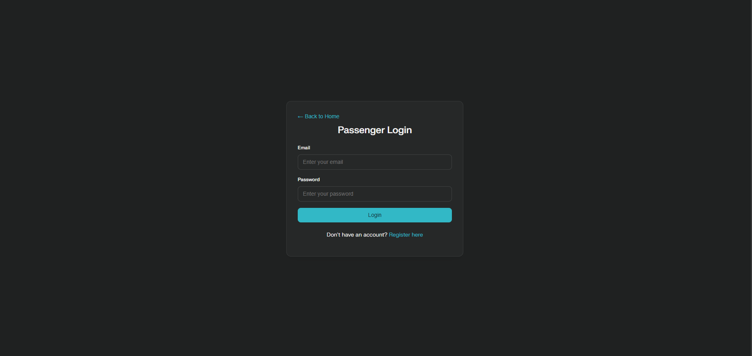
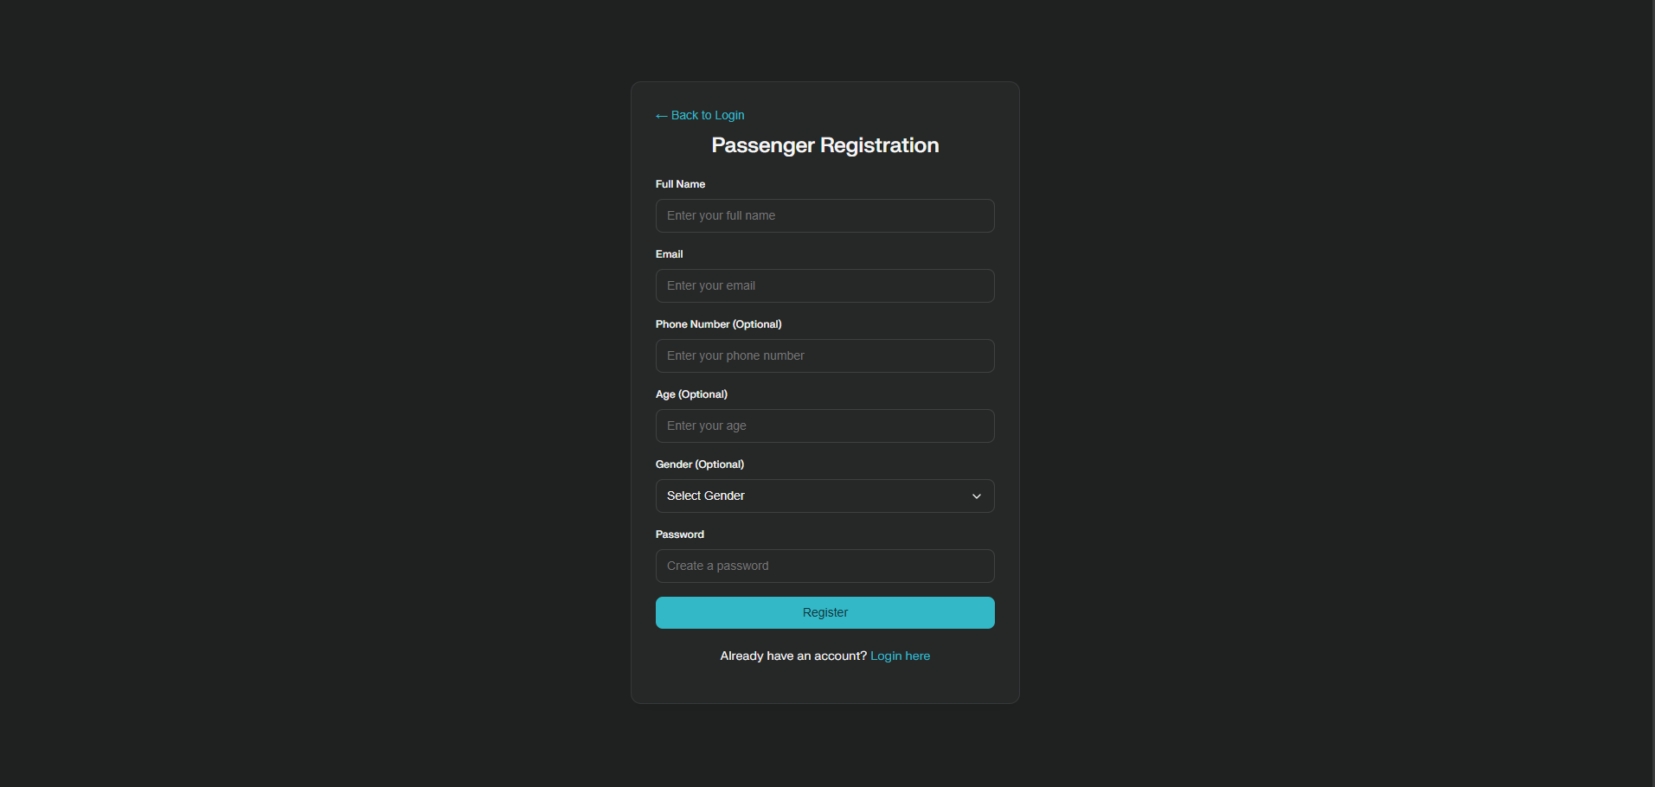

CHAPTER 6
CONCLUSION AND FUTURE ENHANCEMENT
The Railway Management System developed in this project successfully demonstrates a full-stack solution for railway ticketing and train management, integrating multi-class seat selection, real-time booking logic, and admin-side data control. The use of Python backend, MySQL database, and mobile-responsive HTML/CSS frontend delivers a scalable, maintainable, and user-friendly solution for railway operators and passengers alike. The project can be further extended to include payment processing, predictive analytics (using AI/DS methods) for train occupancy, and mobile app integration for more accessibility.

REFERENCES
- https://www.w3schools.com/sql/
- https://www.tutorialspoint.com/sqlite/index.htm
- https://www.wikipedia.org/
- https://www.learnpython.org/
- https://www.codecademy.com/learn/learn-python

